
a
Company
Logotype

Cone Beam Computed Tomography- Report



Porur Dental X-rays & CBCT

Patient Name : Mr. Seshu | Date of Report : 03.06.2024
Age/ Gender : 38 years/ Male | Region of Interest : CBCT Maxilla
Referring doctor: Dr. C. Vijayakrishnan | Indication : Implant assessment of 16, 26.
Clinical Notes: Nil
PATIENT INFORMATION

CBCT- Maxilla provided
CBCT – IMAGE DETAILS

RADIOGRAPHIC INTERPRETATION

- Completely missing crown and root structure in relation to 16, 26.
- The maxillary alveolar ridge is present with normal trabecular pattern.
- Presence of hyperdense crown structures in relation to 11, 21, 22.

IMPLANT ASSESSMENT

 | 16 region | 26 region
Sub-Crestal (in mm)
Mid- Crestal (in mm)
Distance between the alveolar ridge and floor of the maxillary sinus (in mm)

RADIOGRAPHIC IMPRESSION

- Partially edentulous maxillary arch.
- Crown in relation to 11, 21, 22.

Kindly correlate with clinical findings


IMAGES FOR REFERENCE

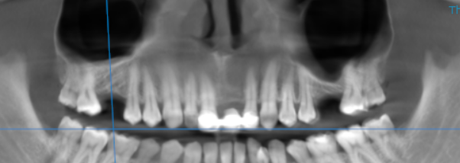

3-DIMENSIONAL VIEW

CROSS SECTIONAL VIEW

16 region
17 region

**** End of report ****

